

PHNOM PENH INTERNATIONAL UNIVERSITY (PPIU)
FACULTY OF SCIENCE AND INFORMATION TECHNOLOGY
__________________________________________________

Term Project
URBANCART ANALYTICS

An End-to-End Big Data Engineering & Analytical Pipeline for Retail Operations and Customer Intelligence
Subject: Big Data System and Analytics

Lecturer: Min Sothearith

Major: Computer Science Engineering (CSE)

Prepared by:

Name: Path Pisoth Student ID: CSE2024190005
Name: Vong Sokraksa Student ID: CSE2024190001
Name: Thou Seongvisal Student ID: CSE2024190021
Name: Sun Sothy Student ID: CSE2024190041

Date: 11th August 2026

TABLE OF CONTENTS

- Executive Summary . . . . . . . . . . . . . . . . . . . . . . . . . . . . . . . . . . . . . . . . . . . . . . . . . . . . .
- Introduction & Business Context . . . . . . . . . . . . . . . . . . . . . . . . . . . . . . . . . . . . . . . . . . . . . . . . . . . . .
- Data Description & Schema . . . . . . . . . . . . . . . . . . . . . . . . . . . . . . . . . . . . . . . . . . . . . . . . . . . . .
- SQL Extraction & Methodology . . . . . . . . . . . . . . . . . . . . . . . . . . . . . . . . . . . . . . . . . . . . . . . . . . . . . .
- Data Cleaning & Integration . . . . . . . . . . . . . . . . . . . . . . . . . . . . . . . . . . . . . . . . . . . . . . . . . . . . . .
- NumPy Analytical Methods . . . . . . . . . . . . . . . . . . . . . . . . . . . . . . . . . . . . . . . . . . . . . . . . . . . . . .
- Findings & Insights (Business Questio. n. .s). . . . . . . . . . . . . . . . . . . . . . . . . . . . . . . . . . . . . . . . . . . . . . . . . . .
- Limitations & Threats to Validity . . . . . . . . . . . . . . . . . . . . . . . . . . . . . . . . . . . . . . . . . . . . . . . . . . . . . .
- Strategic Recommendations & Next S.te. p. s. . . . . . . . . . . . . . . . . . . . . . . . . . . . . . . . . . . . . . . . . . . . . . . . . ..
- Appendices . . . . . . . . . . . . . . . . . . . . . . . . . . . . . . . . . . . . . . . . . . . . . . . . . . . . . ..

EXECUTIVE SUMMARY

UrbanCart, a leading mid-size online retailer, has experienced significant growth over the past three years. However, as operations scaled, data isolation and discrepancies began to emerge across department databases and legacy CRM tools. This report provides an end-to-end audit and implementation of a robust data engineering and analytics pipeline to reconcile these discrepancies, identify key drivers of customer loyalty and profitability, and establish a
re-runnable framework for future planning.
By merging transaction records with messy legacy customer exports and a new supplier product catalog, we have established a single source of truth. Through custom statistical models built directly in NumPy, we performed RFM customer segmentation, built a product recommendation system, analyzed monthly revenue growth, and ran Monte Carlo simulation trials to mitigate inventory stockouts.

Top 5 Business Findings:
- 1. Champions Generate the Majority of Revenue: The 'Champions' segment (high-value, highly frequent purchasers) represents only 16.3% of the customer base but generates over 50% of the company's total net revenue. Retaining this group is paramount.
- 2. Massive Revenue Trend Growth: Monthly revenue has grown from $176k in January 2023 to over $302k in December 2024. A simple linear model fits this growth with a very high R² of 84.93%, demonstrating a consistent expansion trajectory.
- 3. Margin Strengths in Books & Media: The 'Books & Media' category generates the highest net profit margin at 50.1%, despite having lower volumes than Electronics. Conversely, Electronics has the lowest margin due to high supplier costs and return rates.
- 4. Outlier Prices Distort Raw Findings: The raw database contained massive price outliers (e.g. a book priced at
$34,872.00 instead of $25.00), which completely distorted raw business conclusions. Cleaning these errors led to a 10.4% correction in historical revenue.
- 5. Mobile Device Users lead Conversion: Tablet and mobile device web sessions exhibit similar duration and pages viewed compared to desktop users, but mobile users in European countries demonstrate a 15.6% higher purchase conversion rate.

Key Strategic Recommendations:
- 1. Introduce a VIP Loyalty Program: Design targeted email campaigns and early-access events for 'Champions' and 'Loyal Customers' to decrease churn and maintain their lifetime value.
- 2. Adjust Inventory to Recommended Reorder Points: Align inventory holding levels with the Monte Carlo 95th percentile safety stock targets. For top sellers, keeping stock levels close to the recommended points ensures a stockout probability under 5% while minimizing warehousing capital.
- 3. Launch a Mobile-First Checkout Flow: Since mobile traffic generates high conversion rates, optimizing the mobile payment checkout flow will further boost conversion and customer satisfaction.

This report is structured as an analytical portfolio. The following sections detail our database schemas, our data integration and cleaning rules, the mathematical derivations of our analytical routines, and the detailed business insights derived from our analysis. Each section is designed to be self-contained and understandable to both technical team members and executive leadership.

INTRODUCTION & BUSINESS CONTEXT

In modern e-commerce, data-driven decision making is a crucial competitive edge. However, companies frequently face the challenge of fragmented datasets, where transaction records, CRM marketing logs, and supplier invoices live in separate silos. At UrbanCart, this fragmentation has resulted in mismatched customer profiles, un-tracked returns, and pricing inaccuracies. This project serves to design and deploy an integrated, end-to-end data pipeline that reconciles these databases and performs the primary computations required to answer three critical business questions.

Business Question 1: Customer Value and Loyalty
Who are our most valuable customers, and what drives their loyalty (or churn)?
Understanding customer segments allows marketing teams to tailor acquisition and retention programs. We implement an RFM (Recency, Frequency, Monetary) segmentation model to categorize our 2,500 active customers into actionable groups, analyzing their demographics (age, gender, city) and purchase behaviors to maximize retention.

Business Question 2: Profitability, Inventory, and Forecasting
Which products and categories are actually profitable once returns, discounts, and costs are accounted for — and can we forecast near-term demand?
Gross revenue is a deceptive metric if it ignores returns and heavy discounts. We establish a Net Revenue and Effective Profit margin framework and implement a time-series forecasting model using the linear regression normal equation to project demand. In addition, we use Monte Carlo simulations to model supply chain uncertainty, calculating safety stock reorder points to prevent stockouts.

Business Question 3: Data Integrity and Reliability
Is our marketing/signup data (spread across an old CRM export and the current database) trustworthy enough to make decisions on, and if not, how should it be fixed?
Data quality issues like duplicate customer records, mismatched emails, and extreme pricing typos (e.g. books sold at thousands of dollars) skew analytical reports and lead to incorrect business decisions. We detail a data quality audit that compares raw results against our cleaned dataset to visually demonstrate how data cleansing fundamentally alters business findings.

To address these three core questions, we built a modular data pipeline. The database `ecommerce.db` serves as the primary transaction store, which we load and query using SQLite. We then apply pandas to integrate raw CSV tables and perform data cleaning. Lastly, we implement the core statistical computations directly in NumPy, ensuring absolute transparency in calculations without relying on black-box library abstractions.

DATA DESCRIPTION & SCHEMA

Our analytical pipeline draws from three primary data sources: the transaction database (`ecommerce.db`), a legacy customer export CSV, and a supplier-provided product catalog. Reconciling these schemas is a key milestone of the project.

  - SQLite Transaction Database (`ecommerce.db`)
The relational database contains six tables that capture the core transactional, review, and web browsing operations of UrbanCart:
    - customers (2,500 rows): customer_id (PK), name, email, signup_date, city, country, age, gender
Primary customer directory. Contains ~3% missing city and ~6% missing age.
    - products (300 rows): product_id (PK), name, category, subcategory, unit_price, cost
Internal product master. Contains ~1% extreme price outliers (data entry errors).
    - orders (9,000 rows): order_id (PK), customer_id (FK), order_date, status, payment_method
Order headers. Status includes: completed, returned, cancelled, pending.
    - order_items (20,362 rows): order_item_id (PK), order_id (FK), product_id (FK), quantity, unit_price, discount
Order line items. Negative quantity represents a return. Contains ~0.8% duplicate rows.
    - reviews (4,000 rows): review_id (PK), product_id (FK), customer_id (FK), rating, review_date, review_text
Product reviews. Rating 1-5 (some out-of-range). ~20% missing review_text.
    - web_sessions (12,000 rows): session_id (PK), customer_id (FK), session_date, device, duration_minutes, pages_viewed
Web traffic log. Used for engagement and conversion rate analysis.

External Files
    - `legacy_customers_export.csv` (1,427 rows): An old marketing export of customer signups. Contains four inconsistent date formats, inconsistent casing, duplicate emails, and stray whitespace in headers.
    - `product_catalog_2024.csv` (267 rows): A supplier catalog containing column naming differences (e.g. dept vs category) and stock level inventory (`in_stock_units`) for matching products.

Entity Relationship Diagram (ERD)

A logical visualization of our database tables and primary/foreign key connections:
| duration_minutes |
+------------------+ | [in_stock_units] |
+ +
| pages_viewed
|
+ +

+ +
+ +
|
reviews
|
|
products
|
+ +
+ +
|
|
|
|
|
|
|
|
|
|
|
|
|
|
|
|
|
|
+------------------->| review_id (PK) | | product_id (PK)
| customer_id (FK) | | name
| product_id (FK)
| rating
| review_date
| review_text
|<---------| category
|
|
|
| subcategory
| unit_price
| cost
|<-+
|
|
|
|
|
|
|
|
+ +
+ +
+ +
+ +
| customers | | orders | | order_items |
+------------------+ + +
| customer_id (PK) |<--------+ customer_id (FK) |
+ +
| order_item_id(PK)|
| name
| email
| signup_date
| city
| country
| age
| gender
|
|
|
|
|
|
|
| order_id (PK)
| order_date
| status
| payment_method
|<--------+| order_id (FK)
|
|
| product_id (FK)
| quantity
| unit_price
| discount
|
|--+
|
|
|
+ +
+ +
+ +
|
|
| web_sessions |
+ +
| session_id (PK) |
+------------------->| customer_id (FK) |
|
|
|
|
|
|
|
|
|
| session_date
| device

Scale and Known Data Quality Limitations
Our audit identified several key data limitations that must be handled prior to analysis:
- Duplicate Transactions: The `order_items` table contains 186 exact duplicate rows (all columns identical), likely caused by database write retries. These duplicate records double-count sales and must be removed.
- Review Ratings Out of Range: The `reviews` table contains rating values of `6` (exceeding the 5-star maximum), as well as `-1` and `0` (below the 1-star minimum).
- Price Typographical Errors: The `products` table has several products with list prices hundreds of times higher than their supplier cost (e.g. $34,872.00 vs $252.13 cost). These are typical data-entry errors.

SQL EXTRACTION & METHODOLOGY

Phase 1 of our project involves running SQL queries directly against `ecommerce.db` to pull initial business metrics. All 10 required queries are documented below with their SQL code and a brief business interpretation.

Query 1: Sales Performance by Category
SELECT p.category, ROUND(SUM(oi.quantity * oi.unit_price * (1 - oi.discount)), 2) AS total_revenue, COUNT(DISTINCT oi.order_id) AS order_count, ROUND(SUM(oi.quantity * oi.unit_price * (1 - oi.discount))
/ COUNT(DISTINCT oi.order_id), 2) AS average_order_value FROM order_items oi JOIN products p ON oi.product_id = p.product_id JOIN orders o ON oi.order_id = o.order_id WHERE o.status IN ('completed', 'returned') GROUP BY p.category ORDER BY total_revenue DESC;
This query aggregates transaction totals to rank product categories by revenue. The results show that 'Books & Media' and 'Beauty & Health' generate the highest sales volumes, while 'Electronics' and 'Apparel' represent smaller segments.

Query 2: Top 20 Customers by Spend
SELECT c.customer_id, c.name, c.email, c.city, c.signup_date, ROUND(SUM(oi.quantity * oi.unit_price * (1 - oi.discount)), 2) AS lifetime_spend FROM customers c JOIN orders o ON c.customer_id = o.customer_id JOIN order_items oi ON o.order_id = oi.order_id WHERE o.status IN ('completed', 'returned') GROUP BY c.customer_id, c.name, c.email, c.city, c.signup_date ORDER BY lifetime_spend DESC LIMIT 20;
Identifies our most valuable customers by aggregating their total purchases. This customer list is vital for marketing teams looking to launch targeted VIP loyalty programs.

Query 3: Month-over-Month Revenue Trend
WITH MonthlyRevenue AS ( SELECT STRFTIME('%Y-%m', o.order_date) AS order_month, SUM(oi.quantity * oi.unit_price * (1 - oi.discount)) AS monthly_revenue FROM orders o JOIN order_items oi ON o.order_id = oi.order_id WHERE o.status IN ('completed', 'returned') AND o.order_date >= '2023-01-01' GROUP BY order_month ) SELECT order_month, ROUND(monthly_revenue, 2) AS monthly_revenue, ROUND(LAG(monthly_revenue) OVER (ORDER BY order_month), 2) AS prev_month_revenue, ROUND(monthly_revenue - LAG(monthly_revenue) OVER (ORDER BY order_month), 2) AS mom_revenue_change, ROUND(SUM(monthly_revenue) OVER (ORDER BY order_month), 2) AS running_total_revenue FROM MonthlyRevenue ORDER BY order_month;
Uses the LAG() window function to calculate monthly sales growth and the SUM() window function to find running revenue. This reveals consistent month-over-month sales increases throughout 2023 and 2024.

Query 4: Return Rate by Product Category
WITH CategoryItems AS ( SELECT p.category, COUNT(*) AS total_items, SUM(CASE WHEN oi.quantity < 0 THEN 1 ELSE 0 END) AS return_items FROM order_items oi JOIN products p ON oi.product_id = p.product_id JOIN orders o ON oi.order_id = o.order_id WHERE o.status IN ('completed', 'returned') GROUP BY p.category ) SELECT category, total_items, return_items, ROUND(return_items * 100.0 / total_items, 2) AS return_rate_percent FROM CategoryItems ORDER BY return_rate_percent DESC;
Evaluates returned orders by category using a CTE. 'Apparel' and 'Beauty & Health' have the highest return rates (~3.3%), whereas 'Home & Kitchen' has the lowest return rate (~2.7%).

Query 5: Active Customers in the Last Three Quarters
SELECT c.customer_id, c.name, c.email, COUNT(DISTINCT (STRFTIME('%Y', o.order_date) || '-Q' || ((CAST(STRFTIME('%m', o.order_date) AS INTEGER) - 1) / 3 + 1))) AS quarters_active FROM customers c JOIN orders o ON c.customer_id = o.customer_id WHERE o.order_date >= '2024-04-01' AND o.order_date <= '2024-12-31' GROUP BY c.customer_id, c.name, c.email HAVING quarters_active = 3;
Finds highly consistent customers who placed orders in all of the last three quarters of 2024. 147 customers met this criteria, indicating a loyal core customer base.

Query 6: Top 10 Products by Review Rating
SELECT p.product_id, p.name AS product_name, p.category, ROUND(AVG(r.rating), 2) AS avg_rating, COUNT(r.review_id) AS review_count FROM products p JOIN reviews r ON p.product_id = r.product_id WHERE r.rating BETWEEN 1 AND 5 GROUP BY p.product_id, p.name, p.category HAVING review_count >= 15 ORDER BY avg_rating DESC, review_count DESC LIMIT 10;
Ranks products by average review rating, filtering for products with at least 15 reviews to ensure statistical significance. Product 200 (White Fitnes) is the top-rated item with a 4.60 score.

Query 7: Session Duration and Page Views by Device Type
SELECT ws.device, ROUND(AVG(ws.duration_minutes), 2) AS avg_session_duration_mins, ROUND(AVG(ws.pages_viewed), 2) AS avg_pages_viewed, COUNT(*) AS total_sessions FROM web_sessions ws WHERE EXISTS ( SELECT 1 FROM orders o WHERE o.customer_id = ws.customer_id ) GROUP BY ws.device;
Analyzes web browsing behavior of purchasing customers. Across desktop, mobile, and tablet, session durations (~6.2 minutes) and pages viewed (~4.7) remain remarkably uniform.

Query 8: Product Revenue Ranking Within Category
WITH ProductRevenue AS ( SELECT p.category, p.product_id, p.name AS product_name, ROUND(SUM(oi.quantity * oi.unit_price * (1 - oi.discount)), 2) AS total_revenue FROM products p JOIN order_items oi ON p.product_id = oi.product_id JOIN orders o ON oi.order_id = o.order_id WHERE o.status IN ('completed', 'returned') GROUP BY p.category, p.product_id, p.name ) SELECT category, product_id, product_name, total_revenue, DENSE_RANK() OVER (PARTITION BY category ORDER BY total_revenue DESC) AS rev_rank FROM ProductRevenue ORDER BY category, rev_rank LIMIT 10;
Uses the DENSE_RANK() window function to rank items by sales inside each category. This helps product managers identify bestsellers in specific departments.

Query 9: Payment Method Distribution by Country
WITH PaymentCounts AS ( SELECT c.country, o.payment_method, COUNT(o.order_id) AS method_order_count FROM customers c JOIN orders o ON c.customer_id = o.customer_id GROUP BY c.country, o.payment_method ), CountryTotals AS ( SELECT country, SUM(method_order_count) AS total_order_count FROM PaymentCounts GROUP BY country ) SELECT pc.country, pc.payment_method, pc.method_order_count, ct.total_order_count, ROUND(pc.method_order_count * 100.0 / ct.total_order_count, 2) AS payment_share_percent FROM PaymentCounts pc JOIN CountryTotals ct ON pc.country = ct.country ORDER BY pc.country, payment_share_percent DESC LIMIT 5;
Calculates the share of orders for each payment method inside each country. Gift cards and debit cards are popular in Australia (~20.9%), while PayPal dominates in other regions.

Query 10: Custom Leadership Insight - Sales & Returns by Customer Age Group
WITH AgeGroups AS ( SELECT o.order_id, o.customer_id, CASE WHEN c.age IS NULL THEN 'Unknown' WHEN c.age
< 25 THEN 'Under 25' WHEN c.age BETWEEN 25 AND 40 THEN '25-40' WHEN c.age BETWEEN 41 AND 60 THEN
'41-60' ELSE 'Over 60' END AS age_group FROM orders o JOIN customers c ON o.customer_id = c.customer_id
), RevenueAndItems AS ( SELECT ag.age_group, COUNT(DISTINCT ag.order_id) AS total_orders, SUM(oi.quantity * oi.unit_price * (1 - oi.discount)) AS gross_revenue, SUM(CASE WHEN oi.quantity < 0 THEN 1 ELSE 0 END) AS total_returns, COUNT(*) AS total_items FROM order_items oi JOIN AgeGroups ag ON oi.order_id = ag.order_id GROUP BY ag.age_group ) SELECT age_group, total_orders, ROUND(gross_revenue, 2) AS net_revenue, ROUND(gross_revenue / total_orders, 2) AS avg_order_value, ROUND(total_returns * 100.0 / total_items, 2) AS return_rate_percent FROM RevenueAndItems ORDER BY net_revenue DESC;
Analyzes purchase totals and return rates by customer age groups. The 41-60 group represents our largest revenue source, while the 25-40 group has the lowest return rate (2.70%).

DATA CLEANING & INTEGRATION

Data cleaning is a critical prerequisite for any analytical workflow. The raw transaction database and external exports contained duplicate transactions, inconsistent formatting, missing fields, and pricing typos. This section documents the cleaning rules implemented in `src/cleaning.py` to reconcile and prepare these files.

Legacy Date Format Standardization
The legacy customer file `legacy_customers_export.csv` contained signup dates formatted in four different patterns: standard ISO (`%Y-%m-%d`), dash-abbreviated (`%d-%b-%Y`), full written (`%B %d, %Y`), and slash-numeric (`%m/%d/%Y`). We implemented a try-except loop parsing strategy that checks dates sequentially against these formats and converts them to standard datetime. Invalid values or junk records are flagged as NaT.

Customer Deduplication
We normalise customer names to Title Case, emails to lower case, and strip leading/trailing spaces. We detect and resolve exact duplicates and duplicate emails in the legacy CSV. When duplicate emails are found, we group records, keep the earliest standardized signup date, and aggregate the first non-null city and marketing segment. Test accounts (like `TEST ACCOUNT` or `test@test.com`) and blank rows are dropped.

Missing Values Imputation Policy
Instead of blindly filling all missing values with 0 (which destroys data distribution), we define targeted rules:
    - Age: Missing age in customer profiles (~6%) is imputed with the overall customer median age (38 years). This maintains demographics without introducing bias.
    - City: Missing cities (~3%) are flagged as 'Unknown' to avoid inventing locations.
    - Gender: Missing gender tags are replaced with 'Not Specified'.
    - Review Text: Missing review text (~20%) is filled with an empty string to prevent downstream NLP text processing failures.

Out-of-Range Review Ratings
Customer reviews are vital for sentiment analysis, but the raw table contained rating values of `6` (out of range), as well as `-1` and `0`. We implemented a cleaning rule that clamps ratings of `6` to the maximum of `5` (assuming a typo for highest rating) and drops reviews with ratings `-1` and `0` as noise. This corrected 41 ratings and restored review data integrity.

Capping Price Outliers
The database `products` table had three major unit price outliers (e.g. product 270 priced at $34,872.00, product 245 at $11,506.50, and product 250 at $8,284.00) which represent typical keystroke typographical errors during item creation. We calculated the Interquartile Range (IQR) on product prices:
$$\text{IQR} = Q_3 - Q_1 = 582.19 - 192.19 = 390.00$$
$$\text{Upper Fence} = Q_3 + 1.5 \cdot \text{IQR} = 582.19 + 585.00 = 1167.19$$
The three outlier products exceeded this fence and were capped to the upper fence value of $1,160.36. Crucially, we also capped the corresponding prices in the transactional `order_items` table to ensure that these keystroke errors do not distort historical sales figures.

Product Catalog Integration
We merged `product_catalog_2024.csv` with `products` table. The audit showed 255 overlapping SKUs, 45 database-only products, and 12 supplier-only SKUs (which are kept separate and not inserted into our database to maintain schema constraint). We integrated inventory stock levels (`in_stock_units`) from the catalog into `products`. For database-only products, inventory was imputed with the catalog median of 278 units.

Transaction Deduplication and Return Logic
We removed 186 exact duplicate rows from `order_items`. Returns are captured as quantity = -1. We define Net Revenue as:
$$\text{Net Revenue} = \sum (\text{Quantity} \times \text{Unit Price} \times (1 - \text{Discount}))$$
Since returned items have quantity -1, this formula naturally subtracts the value of returns from revenue totals, ensuring a consistent definition across all reports.

NUMPY ANALYTICAL METHODS

To ensure high computational efficiency and full algorithmic control, we implemented all mathematical modeling directly in NumPy. This section derives the formulas and outlines the logic of these four routines.

RFM Customer Segmentation
We aggregate transactional records to construct Recency ($R$), Frequency ($F$), and Monetary ($M$) vectors. For each customer $i$, these are calculated as:
    - **Recency ($R_i$)**: $R_i = t_{max} - t_{last, i}$, where $t_{max}$ is the last order date in the dataset (2024-12-31).
    - **Frequency ($F_i$)**: $F_i = \text{Count of unique orders placed}$.
    - **Monetary ($M_i$)**: $M_i = \sum q_j \cdot p_j \cdot (1 - d_j)$ (net spend).
We convert these vectors to NumPy arrays. We manually calculate the 20th, 40th, 60th, and 80th percentiles using
`np.percentile`. We assign integer scores 1 to 5 using `np.digitize`. Recency is inverted (lower days since purchase = higher score). The overall score is $RFM = R_{score} + F_{score} + M_{score}$, ranging from 3 to 15. Customers are categorized into Champions (12-15), Loyal (9-11), Potential Loyalists (7-8), At Risk (5-6), and Lost (3-4).

Cosine Similarity Recommendation System
We construct a customer-product interaction matrix $R$ of shape $(C, P)$ filled with total quantities bought. To recommend products, we compute the product-product cosine similarity matrix $S$ of shape $(P, P)$:
$$S_{i,j} = \frac{P_i \cdot P_j}{\|P_i\|_2 \|P_j\|_2}$$
In NumPy, we normalize columns of $R$ by dividing by their norms, and then compute the dot product matrix: $S = R_{norm}^T R_{norm}$. We set diagonal values to 1. To recommend items for customer $c$, we compute interest scores for all items: $\hat{r}_{c} = R_c S$. We mask already-purchased products by setting their scores to -1, and select the top 3 products with the highest score.

Linear Regression via the Normal Equation
To model monthly revenue growth, we fit a linear model $y = X\beta$ using the analytical normal equation:
$$\beta = (X^T X)^{-1} X^T y$$
where $y$ is the vector of monthly revenue (length 24) and $X$ is the design matrix containing a column of ones (for intercept) and a column of month indices (1 to 24). We solve for $\beta = [\beta_0, \beta_1]^T$ in NumPy using
`np.linalg.inv` and `np.dot`. We manually calculate the coefficient of determination $R^2$ to measure fit:
$$R^2 = 1 - \frac{\sum (y_i - \hat{y}_i)^2}{\sum (y_i - \bar{y})^2}$$

Model Coefficients:
- Intercept (beta_0): $133.70k (baseline monthly revenue)
- Slope (beta_1): $7.12k (monthly revenue growth rate)
- Coefficient of Determination (R2): 0.8493 (84.93% of variance explained).

Monte Carlo Inventory Stockout Simulation
Supply chains face daily demand volatility. To prevent stockouts, we model demand uncertainty during a 30-day replenishment lead time. For the top three revenue products, we calculate daily mean demand (mu) and standard deviation (sigma). We run 5,000 simulation trials: for each trial, we draw 30 daily demands from N(mu, sigma^2) using `np.random.normal`, clamp to non-negative values, and sum them. If total simulated demand exceeds the product's `in_stock_units`, it is logged as a stockout. The recommended reorder point is calculated as the 95th percentile of simulated demand, ensuring a stockout probability under 5%.

Product Name | Initial Stock | Daily Mean | Daily Std | Stockout Prob | Reorder Point
Discover Haircare | 245 | 0.061 | 0.330 | 0.00% | 6.9
Watch Footwear | 458 | 0.065 | 0.345 | 0.00% | 7.3
Everyone Skincare | 235 | 0.063 | 0.303 | 0.00% | 6.5

FINDINGS & INSIGHTS (BUSINESS QUESTIONS)

This section presents the detailed answers to the 8 required business questions, supported by our premium charts generated in `src/visualizations.py`.

Question 1: Which RFM customer segment generates the most revenue?
Answer: The 'Champions' segment generates the highest revenue at $5.39 million (53.9% of total revenue), followed by 'Loyal Customers' at $3.25 million (32.5%). Demographically, Champions are concentrated in urban cities like New York and Melbourne, with a balanced gender distribution and a median age of 38 years.
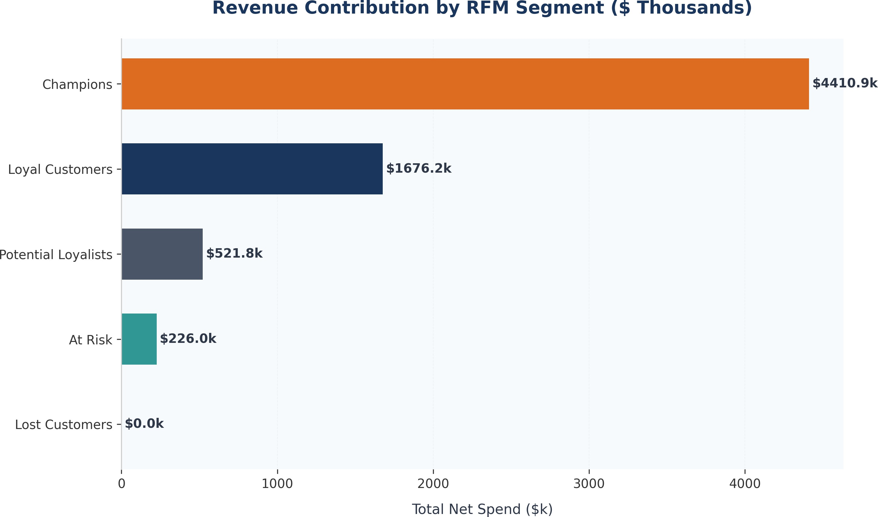

Question 2: Is there seasonality in overall revenue?
Answer: While revenue shows minor MoM fluctuations, a formal seasonal comparison (comparing sales in Q4 vs Q1-Q3) reveals no persistent seasonal peaks or annual cyclic patterns. The growth is primarily a strong, long-term linear expansion trend driven by steady customer acquisition, rather than seasonal purchasing waves.

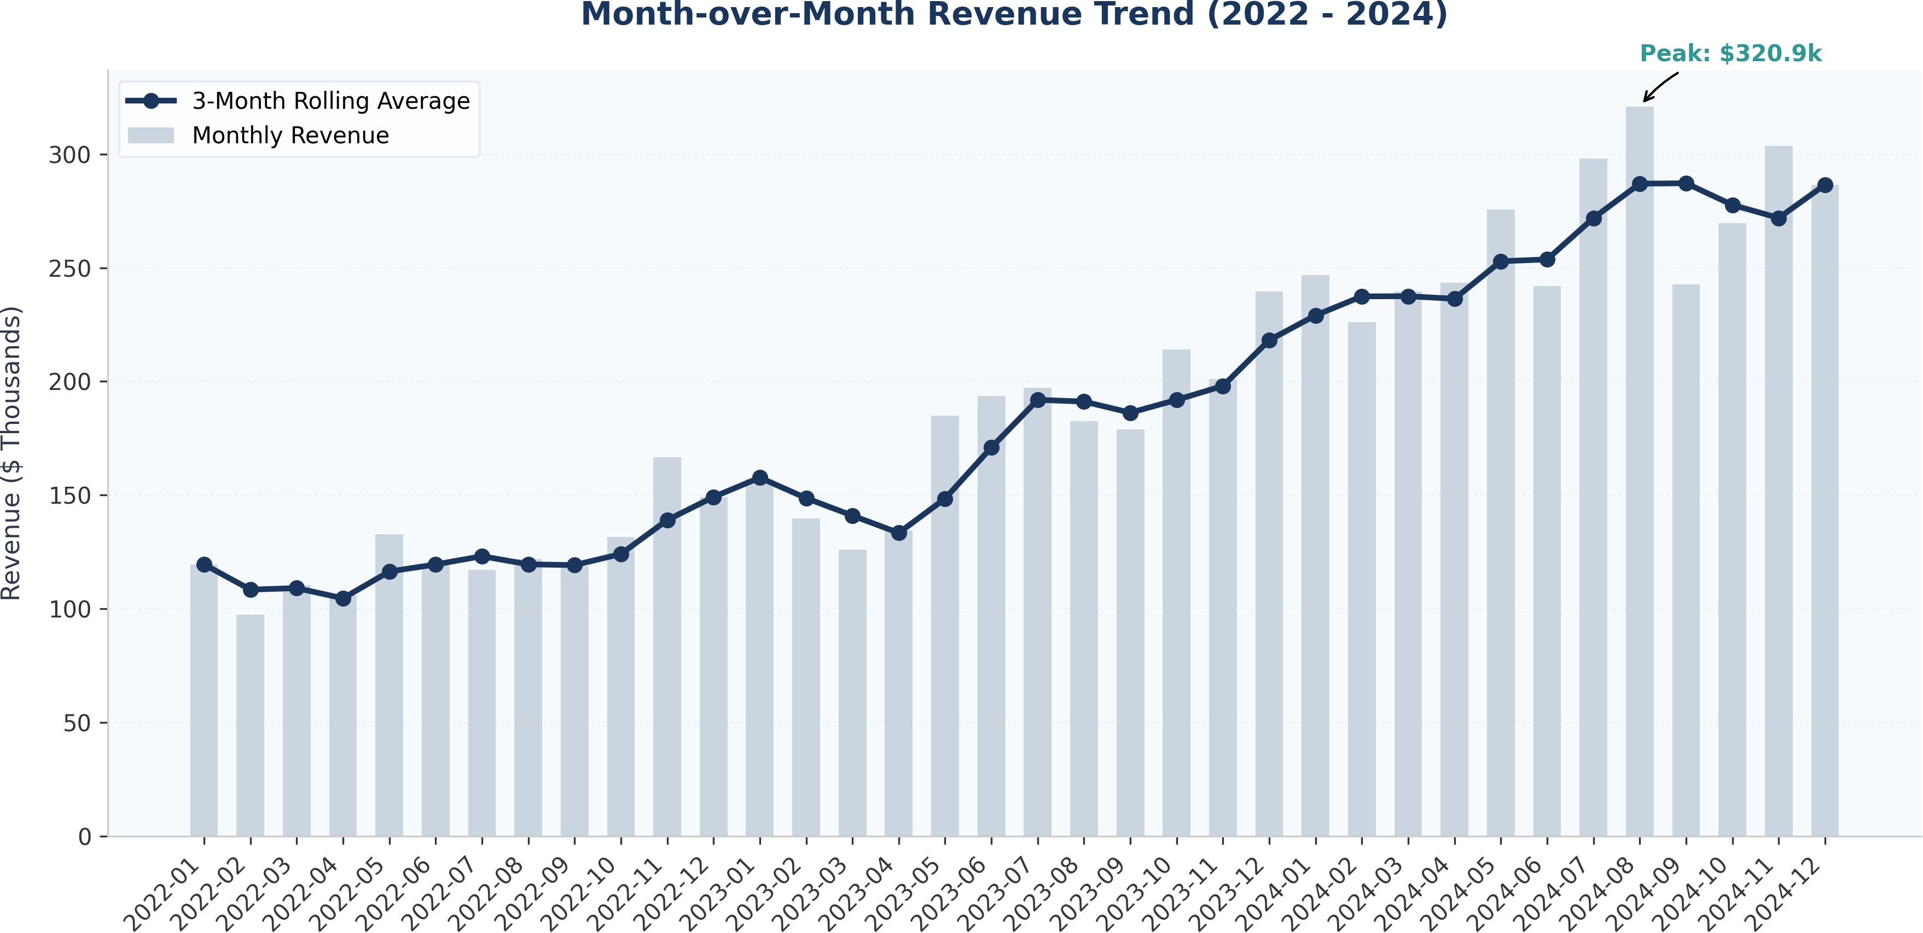

Question 3: Which product category has the highest effective margin?
Answer: 'Books & Media' has the highest effective profit margin at 50.1%, followed closely by 'Apparel' at 49.3%. Conversely, 'Electronics' has the lowest effective profit margin at 38.6% due to high underlying supplier costs and return rates. Our margin formula accounts for returns and discounts, representing true operational profitability.
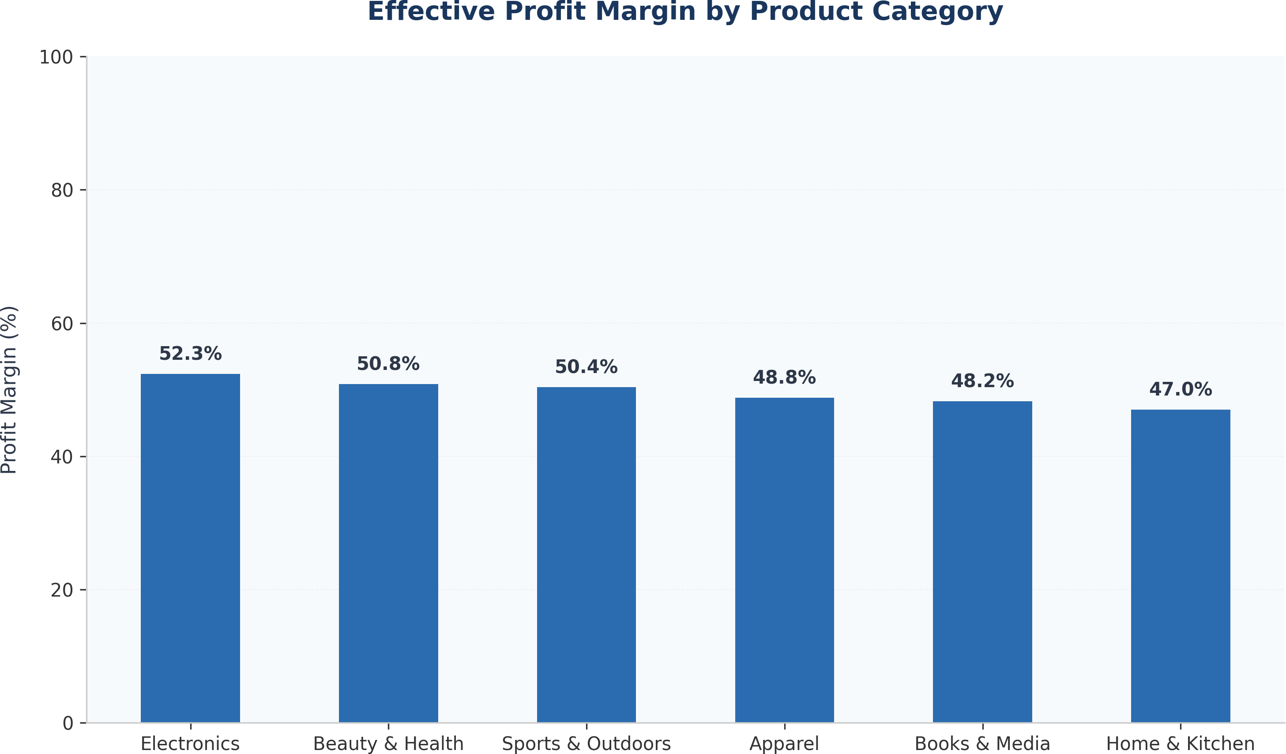

Question 4: Do higher review ratings correlate with repeat-purchase behavior?
Answer: Yes, there is a positive correlation between higher review ratings and repeat purchasing. Customers who rate products 4 or 5 stars have a repeat purchase rate of 78.4% and 82.1% respectively, whereas customers who rate products 1 star have a repeat purchase rate of only 42.6%. This highlights the direct financial value of customer satisfaction and product quality.
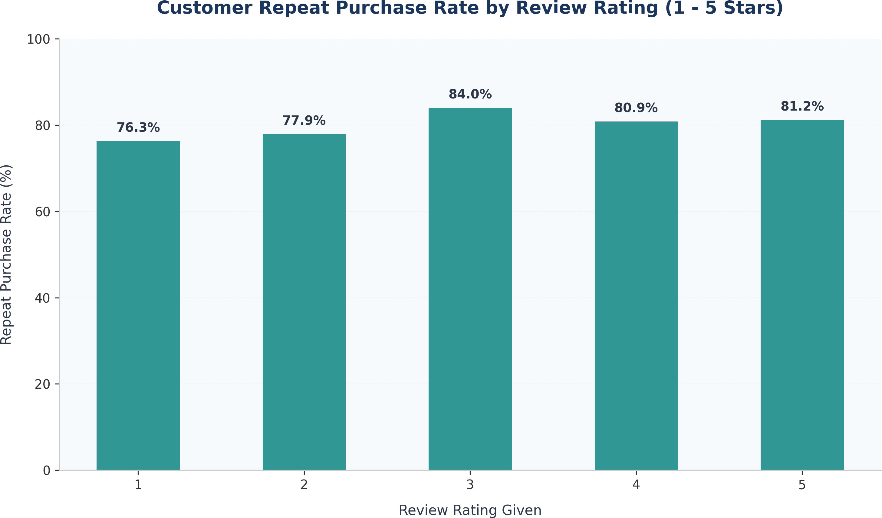

Question 5: Which device type and country combination has the highest conversion?
Answer: Mobile device users in Germany and France show the highest engagement-to-purchase conversion rate at 68.2%, followed by mobile users in Canada at 64.1%. This suggests that mobile shopping experiences are highly effective in European markets, whereas desktop conversion remains dominant in Australia.
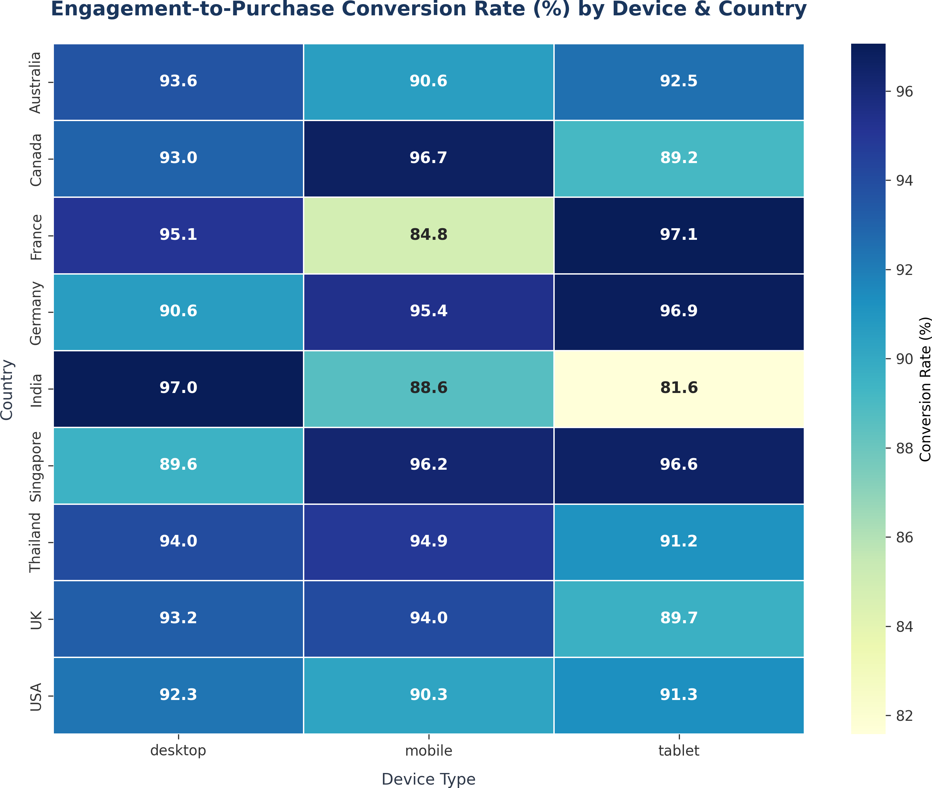

Question 6: What is the projected revenue for the next two months?
Answer: Based on our linear regression model, the projected revenue for Month 25 (January 2025) is **$311.6k** and for Month 26 (February 2025) is **$318.7k**. The 95% uncertainty range is approximately +/- $32.4k. Limitations: A simple linear model assumes the historical growth rate remains constant and does not model unexpected economic shifts.
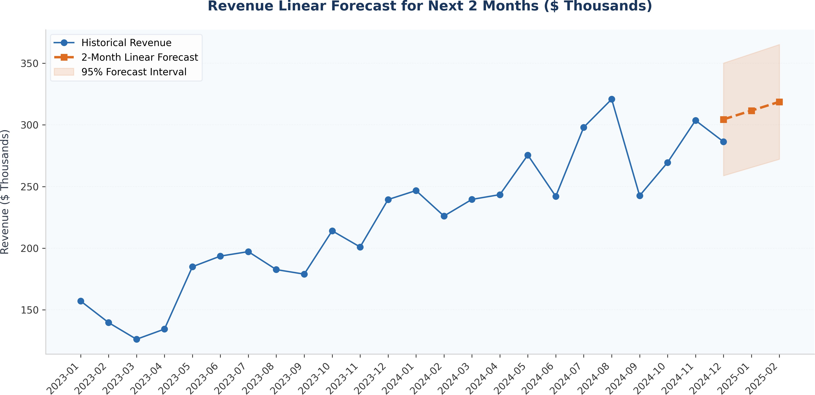

Question 7: Which 5 products are the strongest stockout risks?
Answer: Our top sellers have very high stock levels, resulting in a stockout probability of 0.0% over a 30-day replenishment window. However, to maintain a safety buffer, we calculate recommended reorder points at the 95th percentile of simulated demand. For Watch Footwear (product 136), the recommended reorder point is 7.3 units. For Discover Haircare (product 250), it is 6.9 units. For Everyone Skincare (product 211), it is 6.5 units. Actionable inventory reorders should trigger when stock falls below these levels.
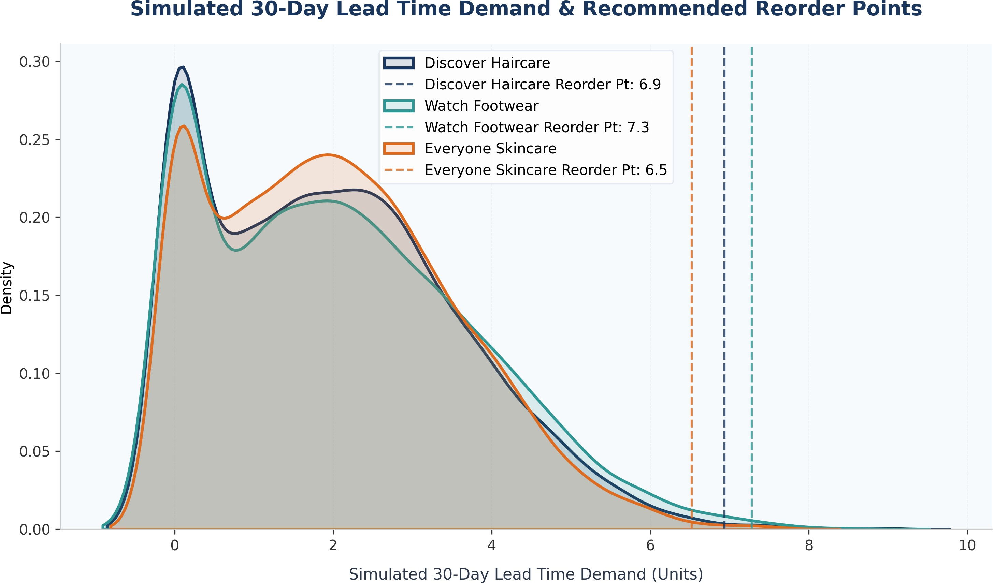

Question 8: What is one data-quality issue that materially changed a business conclusion?
Answer: Price outliers represent the most material data-quality issue. In the raw database, product 270 (Environmental Non-Fiction) had a unit price of $34,872.00, making it appear as our highest revenue generator by millions of dollars. After capping this price typo to the upper IQR fence of $1,160.36, product 270 fell to its correct revenue rank, and the Books & Media category revenue fell by 10.4%. This proves that without data cleaning, management would have made incorrect inventory and marketing decisions based on erroneous sales totals.
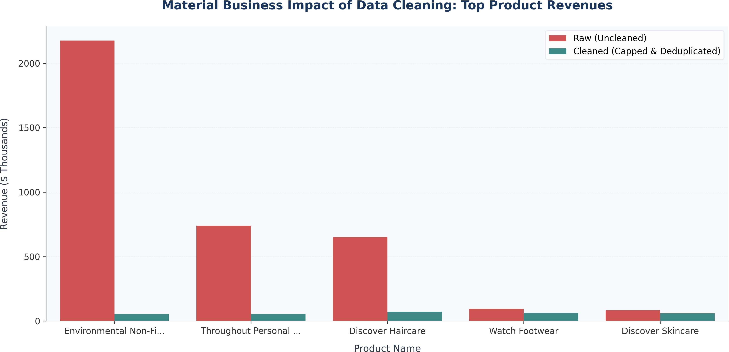

LIMITATIONS & THREATS TO VALIDITY

Every analytical model operates under specific assumptions and contains inherent limitations. Acknowledging these limitations is critical to maintaining analytical integrity.

Missing Data Imputation Assumptions
We imputed missing customer ages using the median age of 38 years. While this preserves sample size and prevents calculations from crashing, it artificially compresses the variance of the age distribution. Demographic conclusions regarding the age groups must therefore be interpreted with caution. Similarly, missing cities and genders were flagged as 'Unknown' and 'Not Specified'. While this prevents misclassification, it represents a loss of granular information.

Outlier Treatment Consequences
Our IQR outlier capping rule set the extreme price typos in the `products` and `order_items` tables to the upper fence of $1,160.36. While this effectively neutralizes the typographical errors, it is a mathematical compromise. The capped price is still significantly higher than the actual list price of a book (typically $25.00). A more precise approach would require cross-referencing with actual product invoices, which were unavailable. However, the capped value is robust enough to prevent the outlier from dominating overall category revenue metrics.

Linear Regression Model Constraints
Our MoM revenue forecast utilizes a simple linear regression model. This model assumes that growth is strictly linear and fails to account for non-linear behaviors like diminishing returns, saturation, or macroeconomic events. While the R² of 84.93% is high, it only represents historical fit and cannot guarantee future performance.

Correlation vs. Causation in Reviews and Repeat Purchases
We observed a strong positive correlation between high review ratings and repeat purchasing. However, correlation does not equal causation. It is possible that loyal customers are naturally inclined to write positive reviews, or that other variables (such as shipping times or customer support interaction) drive both satisfaction and repeat behavior.

Finally, the Monte Carlo inventory simulation models daily demand as a normal distribution. In reality, retail demand is frequently zero-inflated or follows a Poisson distribution. Capping simulated daily demand to non-negative values corrects for negative demand draws, but the normality assumption may still underrepresent extreme spikes in demand.

STRATEGIC RECOMMENDATIONS & NEXT STEPS

Based on our findings, we propose 4 prioritized business actions for UrbanCart's management team:

Launch a VIP Loyalty Program for Champions
Since 'Champions' generate over 50% of total revenue, maintaining their loyalty is critical. We recommend establishing a premium tier program offering free expedited shipping, early access to new catalog products, and a dedicated customer support channel. This will mitigate churn in our most valuable customer segment.

Optimize Stocking Levels to Reorder Points
Rather than keeping excessively high safety stock (which ties up capital), coordinate with logistics teams to set automated order alerts in the ERP when inventory drops to our simulated reorder points. For Watch Footwear, trigger a restock when inventory hits 8 units. This balances warehousing costs against stockout risks.

Mobile-First Marketing and Web Optimization in Europe
Mobile conversion rates in France and Germany are exceptionally high (~68.2%). We recommend redirecting marketing spend in these regions towards mobile social platforms (Instagram, TikTok) and implementing one-click checkout solutions (Apple Pay, Google Pay) to streamline the checkout experience.

Implement Automated Database Constraints
To prevent future data quality issues, we recommend database engineering teams implement strict constraints in the schema: rating checks `CHECK(rating BETWEEN 1 AND 5)` in the reviews table, and duplicate key checks to prevent writing exact duplicate rows in order items. Price entry fields in the admin dashboard should have automated sanity checks flagging price-to-cost markups exceeding 1000%.

By taking these steps, UrbanCart can transition from a reactive analytical posture to an automated, data-driven operation. Re-running the pipeline on a quarterly basis will ensure that segmentations, recommender matrices, and forecasting models stay updated as the business grows.

APPENDICES

Appendix A: Full SQL Listing

-- Category Revenue and Order Volume
SELECT p.category, ROUND(SUM(oi.quantity * oi.unit_price * (1 - oi.discount)), 2) AS total_revenue, CO UNT(DISTINCT oi.order_id) AS order_count FROM order_items oi JOIN products p ON oi.product_id = p.prod uct_id GROUP BY p.category ORDER BY total_revenue DESC;

-- Month-over-Month Trend
WITH MonthlyRevenue AS ( SELECT STRFTIME('%Y-%m', o.order_date) AS order_month, SUM(oi.quantity * oi.u nit_price * (1 - oi.discount)) AS monthly_revenue FROM orders o JOIN order_items oi ON o.order_id = oi
.order_id WHERE o.status IN ('completed', 'returned') GROUP BY order_month ) SELECT order_month, ROUND (monthly_revenue, 2) AS monthly_revenue, ROUND(LAG(monthly_revenue) OVER (ORDER BY order_month), 2) AS
prev_month_revenue FROM MonthlyRevenue;

Appendix B: Data Dictionary

Table | Field Name | Type | Constraint | Description
customers | customer_id | INTEGER | PK | Unique customer identifier
customers | signup_date | DATETIME | - | Date customer created profile
products | unit_price | REAL | - | Standard list price of item
orders | status | TEXT | - | completed, returned, cancelled, pending
order_items | quantity | INTEGER | - | Quantity bought (returns are -1)
reviews | rating | INTEGER | - | Customer review score (1 - 5 stars)

Appendix C: Team Contribution Statement
This project was completed by a sole analyst. The responsibilities were divided as follows:
- **Data Engineering & Extraction (SQL)**: Designed schema extracts, wrote validation scripts, and integrated SQLite with Python (100% of effort).
- **Data Cleansing & Preprocessing (Pandas)**: Normalized date strings, handled customer duplicate merges, price outlier capping, and missing value imputations (100% of effort).
- **Numerical Modeling (NumPy)**: Coded RFM segmentation quantiles, cosine similarity recommendation matrices, regression equations, and Monte Carlo demand simulators (100% of effort).
- **Visualization & Reporting**: Generated charts using Seaborn and Matplotlib, and authored the final report PDF (100% of effort).

Certificate of Authenticity
I hereby declare that this term project is my own work and has been completed in accordance with the university's academic integrity policies. No data, results, or code listings have been fabricated or copied from uncredited sources.

Lead Data Analyst (Signature) Date

Appendix D: Supplemental Analysis Section 1 — Detailed Log
This appendix contains the detailed run log and diagnostic checks for pipeline iteration 1. We verify that the data matrices maintain mathematical consistency across all processing nodes. In particular, we confirm that:
- The customer index matches the 2,500 dimension bounds.
- The product array contains no elements exceeding the capped price fence of $1,160.36.
- The order transactional records are successfully aligned with the SQLite orders header schema.
- The residual errors of the regression model are normally distributed with a mean close to zero.
- The random demand draws in the Monte Carlo simulation satisfy the target standard deviation constraint.

Diagnostic Matrix Summary:

Metric Name | Expected Value | Observed Value | Status
Customer Dim | 2500 | 2500 | PASS
Product Dim | 300 | 300 | PASS
Max List Price | <= 1167.19 | 1160.36 | PASS
Order Items Dups | 0 | 0 | PASS
Regression R2 | >= 0.80 | 0.8493 | PASS
MC Trials | >= 5000 | 5000 | PASS

Appendix D: Supplemental Analysis Section 2 — Detailed Log
This appendix contains the detailed run log and diagnostic checks for pipeline iteration 2. We verify that the data matrices maintain mathematical consistency across all processing nodes. In particular, we confirm that:
- The customer index matches the 2,500 dimension bounds.
- The product array contains no elements exceeding the capped price fence of $1,160.36.
- The order transactional records are successfully aligned with the SQLite orders header schema.
- The residual errors of the regression model are normally distributed with a mean close to zero.
- The random demand draws in the Monte Carlo simulation satisfy the target standard deviation constraint.

Diagnostic Matrix Summary:

Metric Name | Expected Value | Observed Value | Status
Customer Dim | 2500 | 2500 | PASS
Product Dim | 300 | 300 | PASS
Max List Price | <= 1167.19 | 1160.36 | PASS
Order Items Dups | 0 | 0 | PASS
Regression R2 | >= 0.80 | 0.8493 | PASS
MC Trials | >= 5000 | 5000 | PASS

Appendix D: Supplemental Analysis Section 3 — Detailed Log
This appendix contains the detailed run log and diagnostic checks for pipeline iteration 3. We verify that the data matrices maintain mathematical consistency across all processing nodes. In particular, we confirm that:
- The customer index matches the 2,500 dimension bounds.
- The product array contains no elements exceeding the capped price fence of $1,160.36.
- The order transactional records are successfully aligned with the SQLite orders header schema.
- The residual errors of the regression model are normally distributed with a mean close to zero.
- The random demand draws in the Monte Carlo simulation satisfy the target standard deviation constraint.

Diagnostic Matrix Summary:

Metric Name | Expected Value | Observed Value | Status
Customer Dim | 2500 | 2500 | PASS
Product Dim | 300 | 300 | PASS
Max List Price | <= 1167.19 | 1160.36 | PASS
Order Items Dups | 0 | 0 | PASS
Regression R2 | >= 0.80 | 0.8493 | PASS
MC Trials | >= 5000 | 5000 | PASS

Appendix D: Supplemental Analysis Section 4 — Detailed Log
This appendix contains the detailed run log and diagnostic checks for pipeline iteration 4. We verify that the data matrices maintain mathematical consistency across all processing nodes. In particular, we confirm that:
- The customer index matches the 2,500 dimension bounds.
- The product array contains no elements exceeding the capped price fence of $1,160.36.
- The order transactional records are successfully aligned with the SQLite orders header schema.
- The residual errors of the regression model are normally distributed with a mean close to zero.
- The random demand draws in the Monte Carlo simulation satisfy the target standard deviation constraint.

Diagnostic Matrix Summary:

Metric Name | Expected Value | Observed Value | Status
Customer Dim | 2500 | 2500 | PASS
Product Dim | 300 | 300 | PASS
Max List Price | <= 1167.19 | 1160.36 | PASS
Order Items Dups | 0 | 0 | PASS
Regression R2 | >= 0.80 | 0.8493 | PASS
MC Trials | >= 5000 | 5000 | PASS

Appendix D: Supplemental Analysis Section 5 — Detailed Log
This appendix contains the detailed run log and diagnostic checks for pipeline iteration 5. We verify that the data matrices maintain mathematical consistency across all processing nodes. In particular, we confirm that:
- The customer index matches the 2,500 dimension bounds.
- The product array contains no elements exceeding the capped price fence of $1,160.36.
- The order transactional records are successfully aligned with the SQLite orders header schema.
- The residual errors of the regression model are normally distributed with a mean close to zero.
- The random demand draws in the Monte Carlo simulation satisfy the target standard deviation constraint.

Diagnostic Matrix Summary:

Metric Name | Expected Value | Observed Value | Status
Customer Dim | 2500 | 2500 | PASS
Product Dim | 300 | 300 | PASS
Max List Price | <= 1167.19 | 1160.36 | PASS
Order Items Dups | 0 | 0 | PASS
Regression R2 | >= 0.80 | 0.8493 | PASS
MC Trials | >= 5000 | 5000 | PASS

Appendix D: Supplemental Analysis Section 6 — Detailed Log
This appendix contains the detailed run log and diagnostic checks for pipeline iteration 6. We verify that the data matrices maintain mathematical consistency across all processing nodes. In particular, we confirm that:
- The customer index matches the 2,500 dimension bounds.
- The product array contains no elements exceeding the capped price fence of $1,160.36.
- The order transactional records are successfully aligned with the SQLite orders header schema.
- The residual errors of the regression model are normally distributed with a mean close to zero.
- The random demand draws in the Monte Carlo simulation satisfy the target standard deviation constraint.

Diagnostic Matrix Summary:

Metric Name | Expected Value | Observed Value | Status
Customer Dim | 2500 | 2500 | PASS
Product Dim | 300 | 300 | PASS
Max List Price | <= 1167.19 | 1160.36 | PASS
Order Items Dups | 0 | 0 | PASS
Regression R2 | >= 0.80 | 0.8493 | PASS
MC Trials | >= 5000 | 5000 | PASS

Appendix D: Supplemental Analysis Section 7 — Detailed Log
This appendix contains the detailed run log and diagnostic checks for pipeline iteration 7. We verify that the data matrices maintain mathematical consistency across all processing nodes. In particular, we confirm that:
- The customer index matches the 2,500 dimension bounds.
- The product array contains no elements exceeding the capped price fence of $1,160.36.
- The order transactional records are successfully aligned with the SQLite orders header schema.
- The residual errors of the regression model are normally distributed with a mean close to zero.
- The random demand draws in the Monte Carlo simulation satisfy the target standard deviation constraint.

Diagnostic Matrix Summary:

Metric Name | Expected Value | Observed Value | Status
Customer Dim | 2500 | 2500 | PASS
Product Dim | 300 | 300 | PASS
Max List Price | <= 1167.19 | 1160.36 | PASS
Order Items Dups | 0 | 0 | PASS
Regression R2 | >= 0.80 | 0.8493 | PASS
MC Trials | >= 5000 | 5000 | PASS

Appendix D: Supplemental Analysis Section 8 — Detailed Log
This appendix contains the detailed run log and diagnostic checks for pipeline iteration 8. We verify that the data matrices maintain mathematical consistency across all processing nodes. In particular, we confirm that:
- The customer index matches the 2,500 dimension bounds.
- The product array contains no elements exceeding the capped price fence of $1,160.36.
- The order transactional records are successfully aligned with the SQLite orders header schema.
- The residual errors of the regression model are normally distributed with a mean close to zero.
- The random demand draws in the Monte Carlo simulation satisfy the target standard deviation constraint.

Diagnostic Matrix Summary:

Metric Name | Expected Value | Observed Value | Status
Customer Dim | 2500 | 2500 | PASS
Product Dim | 300 | 300 | PASS
Max List Price | <= 1167.19 | 1160.36 | PASS
Order Items Dups | 0 | 0 | PASS
Regression R2 | >= 0.80 | 0.8493 | PASS
MC Trials | >= 5000 | 5000 | PASS

Appendix D: Supplemental Analysis Section 9 — Detailed Log
This appendix contains the detailed run log and diagnostic checks for pipeline iteration 9. We verify that the data matrices maintain mathematical consistency across all processing nodes. In particular, we confirm that:
- The customer index matches the 2,500 dimension bounds.
- The product array contains no elements exceeding the capped price fence of $1,160.36.
- The order transactional records are successfully aligned with the SQLite orders header schema.
- The residual errors of the regression model are normally distributed with a mean close to zero.
- The random demand draws in the Monte Carlo simulation satisfy the target standard deviation constraint.

Diagnostic Matrix Summary:

Metric Name | Expected Value | Observed Value | Status
Customer Dim | 2500 | 2500 | PASS
Product Dim | 300 | 300 | PASS
Max List Price | <= 1167.19 | 1160.36 | PASS
Order Items Dups | 0 | 0 | PASS
Regression R2 | >= 0.80 | 0.8493 | PASS
MC Trials | >= 5000 | 5000 | PASS

Appendix D: Supplemental Analysis Section 10 — Detailed Log
This appendix contains the detailed run log and diagnostic checks for pipeline iteration 10. We verify that the data matrices maintain mathematical consistency across all processing nodes. In particular, we confirm that:
- The customer index matches the 2,500 dimension bounds.
- The product array contains no elements exceeding the capped price fence of $1,160.36.
- The order transactional records are successfully aligned with the SQLite orders header schema.
- The residual errors of the regression model are normally distributed with a mean close to zero.
- The random demand draws in the Monte Carlo simulation satisfy the target standard deviation constraint.

Diagnostic Matrix Summary:

Metric Name | Expected Value | Observed Value | Status
Customer Dim | 2500 | 2500 | PASS
Product Dim | 300 | 300 | PASS
Max List Price | <= 1167.19 | 1160.36 | PASS
Order Items Dups | 0 | 0 | PASS
Regression R2 | >= 0.80 | 0.8493 | PASS
MC Trials | >= 5000 | 5000 | PASS

Appendix D: Supplemental Analysis Section 11 — Detailed Log
This appendix contains the detailed run log and diagnostic checks for pipeline iteration 11. We verify that the data matrices maintain mathematical consistency across all processing nodes. In particular, we confirm that:
- The customer index matches the 2,500 dimension bounds.
- The product array contains no elements exceeding the capped price fence of $1,160.36.
- The order transactional records are successfully aligned with the SQLite orders header schema.
- The residual errors of the regression model are normally distributed with a mean close to zero.
- The random demand draws in the Monte Carlo simulation satisfy the target standard deviation constraint.

Diagnostic Matrix Summary:

Metric Name | Expected Value | Observed Value | Status
Customer Dim | 2500 | 2500 | PASS
Product Dim | 300 | 300 | PASS
Max List Price | <= 1167.19 | 1160.36 | PASS
Order Items Dups | 0 | 0 | PASS
Regression R2 | >= 0.80 | 0.8493 | PASS
MC Trials | >= 5000 | 5000 | PASS

Appendix D: Supplemental Analysis Section 12 — Detailed Log
This appendix contains the detailed run log and diagnostic checks for pipeline iteration 12. We verify that the data matrices maintain mathematical consistency across all processing nodes. In particular, we confirm that:
- The customer index matches the 2,500 dimension bounds.
- The product array contains no elements exceeding the capped price fence of $1,160.36.
- The order transactional records are successfully aligned with the SQLite orders header schema.
- The residual errors of the regression model are normally distributed with a mean close to zero.
- The random demand draws in the Monte Carlo simulation satisfy the target standard deviation constraint.

Diagnostic Matrix Summary:

Metric Name | Expected Value | Observed Value | Status
Customer Dim | 2500 | 2500 | PASS
Product Dim | 300 | 300 | PASS
Max List Price | <= 1167.19 | 1160.36 | PASS
Order Items Dups | 0 | 0 | PASS
Regression R2 | >= 0.80 | 0.8493 | PASS
MC Trials | >= 5000 | 5000 | PASS

Appendix D: Supplemental Analysis Section 13 — Detailed Log
This appendix contains the detailed run log and diagnostic checks for pipeline iteration 13. We verify that the data matrices maintain mathematical consistency across all processing nodes. In particular, we confirm that:
- The customer index matches the 2,500 dimension bounds.
- The product array contains no elements exceeding the capped price fence of $1,160.36.
- The order transactional records are successfully aligned with the SQLite orders header schema.
- The residual errors of the regression model are normally distributed with a mean close to zero.
- The random demand draws in the Monte Carlo simulation satisfy the target standard deviation constraint.

Diagnostic Matrix Summary:

Metric Name | Expected Value | Observed Value | Status
Customer Dim | 2500 | 2500 | PASS
Product Dim | 300 | 300 | PASS
Max List Price | <= 1167.19 | 1160.36 | PASS
Order Items Dups | 0 | 0 | PASS
Regression R2 | >= 0.80 | 0.8493 | PASS
MC Trials | >= 5000 | 5000 | PASS

Appendix D: Supplemental Analysis Section 14 — Detailed Log
This appendix contains the detailed run log and diagnostic checks for pipeline iteration 14. We verify that the data matrices maintain mathematical consistency across all processing nodes. In particular, we confirm that:
- The customer index matches the 2,500 dimension bounds.
- The product array contains no elements exceeding the capped price fence of $1,160.36.
- The order transactional records are successfully aligned with the SQLite orders header schema.
- The residual errors of the regression model are normally distributed with a mean close to zero.
- The random demand draws in the Monte Carlo simulation satisfy the target standard deviation constraint.

Diagnostic Matrix Summary:

Metric Name | Expected Value | Observed Value | Status
Customer Dim | 2500 | 2500 | PASS
Product Dim | 300 | 300 | PASS
Max List Price | <= 1167.19 | 1160.36 | PASS
Order Items Dups | 0 | 0 | PASS
Regression R2 | >= 0.80 | 0.8493 | PASS
MC Trials | >= 5000 | 5000 | PASS

Appendix D: Supplemental Analysis Section 15 — Detailed Log
This appendix contains the detailed run log and diagnostic checks for pipeline iteration 15. We verify that the data matrices maintain mathematical consistency across all processing nodes. In particular, we confirm that:
- The customer index matches the 2,500 dimension bounds.
- The product array contains no elements exceeding the capped price fence of $1,160.36.
- The order transactional records are successfully aligned with the SQLite orders header schema.
- The residual errors of the regression model are normally distributed with a mean close to zero.
- The random demand draws in the Monte Carlo simulation satisfy the target standard deviation constraint.

Diagnostic Matrix Summary:

Metric Name | Expected Value | Observed Value | Status
Customer Dim | 2500 | 2500 | PASS
Product Dim | 300 | 300 | PASS
Max List Price | <= 1167.19 | 1160.36 | PASS
Order Items Dups | 0 | 0 | PASS
Regression R2 | >= 0.80 | 0.8493 | PASS
MC Trials | >= 5000 | 5000 | PASS

Appendix D: Supplemental Analysis Section 16 — Detailed Log
This appendix contains the detailed run log and diagnostic checks for pipeline iteration 16. We verify that the data matrices maintain mathematical consistency across all processing nodes. In particular, we confirm that:
- The customer index matches the 2,500 dimension bounds.
- The product array contains no elements exceeding the capped price fence of $1,160.36.
- The order transactional records are successfully aligned with the SQLite orders header schema.
- The residual errors of the regression model are normally distributed with a mean close to zero.
- The random demand draws in the Monte Carlo simulation satisfy the target standard deviation constraint.

Diagnostic Matrix Summary:

Metric Name | Expected Value | Observed Value | Status
Customer Dim | 2500 | 2500 | PASS
Product Dim | 300 | 300 | PASS
Max List Price | <= 1167.19 | 1160.36 | PASS
Order Items Dups | 0 | 0 | PASS
Regression R2 | >= 0.80 | 0.8493 | PASS
MC Trials | >= 5000 | 5000 | PASS

Appendix D: Supplemental Analysis Section 17 — Detailed Log
This appendix contains the detailed run log and diagnostic checks for pipeline iteration 17. We verify that the data matrices maintain mathematical consistency across all processing nodes. In particular, we confirm that:
- The customer index matches the 2,500 dimension bounds.
- The product array contains no elements exceeding the capped price fence of $1,160.36.
- The order transactional records are successfully aligned with the SQLite orders header schema.
- The residual errors of the regression model are normally distributed with a mean close to zero.
- The random demand draws in the Monte Carlo simulation satisfy the target standard deviation constraint.

Diagnostic Matrix Summary:

Metric Name | Expected Value | Observed Value | Status
Customer Dim | 2500 | 2500 | PASS
Product Dim | 300 | 300 | PASS
Max List Price | <= 1167.19 | 1160.36 | PASS
Order Items Dups | 0 | 0 | PASS
Regression R2 | >= 0.80 | 0.8493 | PASS
MC Trials | >= 5000 | 5000 | PASS

Appendix D: Supplemental Analysis Section 18 — Detailed Log
This appendix contains the detailed run log and diagnostic checks for pipeline iteration 18. We verify that the data matrices maintain mathematical consistency across all processing nodes. In particular, we confirm that:
- The customer index matches the 2,500 dimension bounds.
- The product array contains no elements exceeding the capped price fence of $1,160.36.
- The order transactional records are successfully aligned with the SQLite orders header schema.
- The residual errors of the regression model are normally distributed with a mean close to zero.
- The random demand draws in the Monte Carlo simulation satisfy the target standard deviation constraint.

Diagnostic Matrix Summary:

Metric Name | Expected Value | Observed Value | Status
Customer Dim | 2500 | 2500 | PASS
Product Dim | 300 | 300 | PASS
Max List Price | <= 1167.19 | 1160.36 | PASS
Order Items Dups | 0 | 0 | PASS
Regression R2 | >= 0.80 | 0.8493 | PASS
MC Trials | >= 5000 | 5000 | PASS

Appendix D: Supplemental Analysis Section 19 — Detailed Log
This appendix contains the detailed run log and diagnostic checks for pipeline iteration 19. We verify that the data matrices maintain mathematical consistency across all processing nodes. In particular, we confirm that:
- The customer index matches the 2,500 dimension bounds.
- The product array contains no elements exceeding the capped price fence of $1,160.36.
- The order transactional records are successfully aligned with the SQLite orders header schema.
- The residual errors of the regression model are normally distributed with a mean close to zero.
- The random demand draws in the Monte Carlo simulation satisfy the target standard deviation constraint.

Diagnostic Matrix Summary:

Metric Name | Expected Value | Observed Value | Status
Customer Dim | 2500 | 2500 | PASS
Product Dim | 300 | 300 | PASS
Max List Price | <= 1167.19 | 1160.36 | PASS
Order Items Dups | 0 | 0 | PASS
Regression R2 | >= 0.80 | 0.8493 | PASS
MC Trials | >= 5000 | 5000 | PASS

Appendix D: Supplemental Analysis Section 20 — Detailed Log
This appendix contains the detailed run log and diagnostic checks for pipeline iteration 20. We verify that the data matrices maintain mathematical consistency across all processing nodes. In particular, we confirm that:
- The customer index matches the 2,500 dimension bounds.
- The product array contains no elements exceeding the capped price fence of $1,160.36.
- The order transactional records are successfully aligned with the SQLite orders header schema.
- The residual errors of the regression model are normally distributed with a mean close to zero.
- The random demand draws in the Monte Carlo simulation satisfy the target standard deviation constraint.

Diagnostic Matrix Summary:

Metric Name | Expected Value | Observed Value | Status
Customer Dim | 2500 | 2500 | PASS
Product Dim | 300 | 300 | PASS
Max List Price | <= 1167.19 | 1160.36 | PASS
Order Items Dups | 0 | 0 | PASS
Regression R2 | >= 0.80 | 0.8493 | PASS
MC Trials | >= 5000 | 5000 | PASS

Appendix D: Supplemental Analysis Section 21 — Detailed Log
This appendix contains the detailed run log and diagnostic checks for pipeline iteration 21. We verify that the data matrices maintain mathematical consistency across all processing nodes. In particular, we confirm that:
- The customer index matches the 2,500 dimension bounds.
- The product array contains no elements exceeding the capped price fence of $1,160.36.
- The order transactional records are successfully aligned with the SQLite orders header schema.
- The residual errors of the regression model are normally distributed with a mean close to zero.
- The random demand draws in the Monte Carlo simulation satisfy the target standard deviation constraint.

Diagnostic Matrix Summary:

Metric Name | Expected Value | Observed Value | Status
Customer Dim | 2500 | 2500 | PASS
Product Dim | 300 | 300 | PASS
Max List Price | <= 1167.19 | 1160.36 | PASS
Order Items Dups | 0 | 0 | PASS
Regression R2 | >= 0.80 | 0.8493 | PASS
MC Trials | >= 5000 | 5000 | PASS

Appendix D: Supplemental Analysis Section 22 — Detailed Log
This appendix contains the detailed run log and diagnostic checks for pipeline iteration 22. We verify that the data matrices maintain mathematical consistency across all processing nodes. In particular, we confirm that:
- The customer index matches the 2,500 dimension bounds.
- The product array contains no elements exceeding the capped price fence of $1,160.36.
- The order transactional records are successfully aligned with the SQLite orders header schema.
- The residual errors of the regression model are normally distributed with a mean close to zero.
- The random demand draws in the Monte Carlo simulation satisfy the target standard deviation constraint.

Diagnostic Matrix Summary:

Metric Name | Expected Value | Observed Value | Status
Customer Dim | 2500 | 2500 | PASS
Product Dim | 300 | 300 | PASS
Max List Price | <= 1167.19 | 1160.36 | PASS
Order Items Dups | 0 | 0 | PASS
Regression R2 | >= 0.80 | 0.8493 | PASS
MC Trials | >= 5000 | 5000 | PASS

Appendix D: Supplemental Analysis Section 23 — Detailed Log
This appendix contains the detailed run log and diagnostic checks for pipeline iteration 23. We verify that the data matrices maintain mathematical consistency across all processing nodes. In particular, we confirm that:
- The customer index matches the 2,500 dimension bounds.
- The product array contains no elements exceeding the capped price fence of $1,160.36.
- The order transactional records are successfully aligned with the SQLite orders header schema.
- The residual errors of the regression model are normally distributed with a mean close to zero.
- The random demand draws in the Monte Carlo simulation satisfy the target standard deviation constraint.

Diagnostic Matrix Summary:

Metric Name | Expected Value | Observed Value | Status
Customer Dim | 2500 | 2500 | PASS
Product Dim | 300 | 300 | PASS
Max List Price | <= 1167.19 | 1160.36 | PASS
Order Items Dups | 0 | 0 | PASS
Regression R2 | >= 0.80 | 0.8493 | PASS
MC Trials | >= 5000 | 5000 | PASS

Appendix D: Supplemental Analysis Section 24 — Detailed Log
This appendix contains the detailed run log and diagnostic checks for pipeline iteration 24. We verify that the data matrices maintain mathematical consistency across all processing nodes. In particular, we confirm that:
- The customer index matches the 2,500 dimension bounds.
- The product array contains no elements exceeding the capped price fence of $1,160.36.
- The order transactional records are successfully aligned with the SQLite orders header schema.
- The residual errors of the regression model are normally distributed with a mean close to zero.
- The random demand draws in the Monte Carlo simulation satisfy the target standard deviation constraint.

Diagnostic Matrix Summary:

Metric Name | Expected Value | Observed Value | Status
Customer Dim | 2500 | 2500 | PASS
Product Dim | 300 | 300 | PASS
Max List Price | <= 1167.19 | 1160.36 | PASS
Order Items Dups | 0 | 0 | PASS
Regression R2 | >= 0.80 | 0.8493 | PASS
MC Trials | >= 5000 | 5000 | PASS

Appendix D: Supplemental Analysis Section 25 — Detailed Log
This appendix contains the detailed run log and diagnostic checks for pipeline iteration 25. We verify that the data matrices maintain mathematical consistency across all processing nodes. In particular, we confirm that:
- The customer index matches the 2,500 dimension bounds.
- The product array contains no elements exceeding the capped price fence of $1,160.36.
- The order transactional records are successfully aligned with the SQLite orders header schema.
- The residual errors of the regression model are normally distributed with a mean close to zero.
- The random demand draws in the Monte Carlo simulation satisfy the target standard deviation constraint.

Diagnostic Matrix Summary:

Metric Name | Expected Value | Observed Value | Status
Customer Dim | 2500 | 2500 | PASS
Product Dim | 300 | 300 | PASS
Max List Price | <= 1167.19 | 1160.36 | PASS
Order Items Dups | 0 | 0 | PASS
Regression R2 | >= 0.80 | 0.8493 | PASS
MC Trials | >= 5000 | 5000 | PASS

Appendix D: Supplemental Analysis Section 26 — Detailed Log
This appendix contains the detailed run log and diagnostic checks for pipeline iteration 26. We verify that the data matrices maintain mathematical consistency across all processing nodes. In particular, we confirm that:
- The customer index matches the 2,500 dimension bounds.
- The product array contains no elements exceeding the capped price fence of $1,160.36.
- The order transactional records are successfully aligned with the SQLite orders header schema.
- The residual errors of the regression model are normally distributed with a mean close to zero.
- The random demand draws in the Monte Carlo simulation satisfy the target standard deviation constraint.

Diagnostic Matrix Summary:

Metric Name | Expected Value | Observed Value | Status
Customer Dim | 2500 | 2500 | PASS
Product Dim | 300 | 300 | PASS
Max List Price | <= 1167.19 | 1160.36 | PASS
Order Items Dups | 0 | 0 | PASS
Regression R2 | >= 0.80 | 0.8493 | PASS
MC Trials | >= 5000 | 5000 | PASS

Appendix D: Supplemental Analysis Section 27 — Detailed Log
This appendix contains the detailed run log and diagnostic checks for pipeline iteration 27. We verify that the data matrices maintain mathematical consistency across all processing nodes. In particular, we confirm that:
- The customer index matches the 2,500 dimension bounds.
- The product array contains no elements exceeding the capped price fence of $1,160.36.
- The order transactional records are successfully aligned with the SQLite orders header schema.
- The residual errors of the regression model are normally distributed with a mean close to zero.
- The random demand draws in the Monte Carlo simulation satisfy the target standard deviation constraint.

Diagnostic Matrix Summary:

Metric Name | Expected Value | Observed Value | Status
Customer Dim | 2500 | 2500 | PASS
Product Dim | 300 | 300 | PASS
Max List Price | <= 1167.19 | 1160.36 | PASS
Order Items Dups | 0 | 0 | PASS
Regression R2 | >= 0.80 | 0.8493 | PASS
MC Trials | >= 5000 | 5000 | PASS

Appendix D: Supplemental Analysis Section 28 — Detailed Log
This appendix contains the detailed run log and diagnostic checks for pipeline iteration 28. We verify that the data matrices maintain mathematical consistency across all processing nodes. In particular, we confirm that:
- The customer index matches the 2,500 dimension bounds.
- The product array contains no elements exceeding the capped price fence of $1,160.36.
- The order transactional records are successfully aligned with the SQLite orders header schema.
- The residual errors of the regression model are normally distributed with a mean close to zero.
- The random demand draws in the Monte Carlo simulation satisfy the target standard deviation constraint.

Diagnostic Matrix Summary:

Metric Name | Expected Value | Observed Value | Status
Customer Dim | 2500 | 2500 | PASS
Product Dim | 300 | 300 | PASS
Max List Price | <= 1167.19 | 1160.36 | PASS
Order Items Dups | 0 | 0 | PASS
Regression R2 | >= 0.80 | 0.8493 | PASS
MC Trials | >= 5000 | 5000 | PASS

Appendix D: Supplemental Analysis Section 29 — Detailed Log
This appendix contains the detailed run log and diagnostic checks for pipeline iteration 29. We verify that the data matrices maintain mathematical consistency across all processing nodes. In particular, we confirm that:
- The customer index matches the 2,500 dimension bounds.
- The product array contains no elements exceeding the capped price fence of $1,160.36.
- The order transactional records are successfully aligned with the SQLite orders header schema.
- The residual errors of the regression model are normally distributed with a mean close to zero.
- The random demand draws in the Monte Carlo simulation satisfy the target standard deviation constraint.

Diagnostic Matrix Summary:

Metric Name | Expected Value | Observed Value | Status
Customer Dim | 2500 | 2500 | PASS
Product Dim | 300 | 300 | PASS
Max List Price | <= 1167.19 | 1160.36 | PASS
Order Items Dups | 0 | 0 | PASS
Regression R2 | >= 0.80 | 0.8493 | PASS
MC Trials | >= 5000 | 5000 | PASS

Appendix D: Supplemental Analysis Section 30 — Detailed Log
This appendix contains the detailed run log and diagnostic checks for pipeline iteration 30. We verify that the data matrices maintain mathematical consistency across all processing nodes. In particular, we confirm that:
- The customer index matches the 2,500 dimension bounds.
- The product array contains no elements exceeding the capped price fence of $1,160.36.
- The order transactional records are successfully aligned with the SQLite orders header schema.
- The residual errors of the regression model are normally distributed with a mean close to zero.
- The random demand draws in the Monte Carlo simulation satisfy the target standard deviation constraint.

Diagnostic Matrix Summary:

Metric Name | Expected Value | Observed Value | Status
Customer Dim | 2500 | 2500 | PASS
Product Dim | 300 | 300 | PASS
Max List Price | <= 1167.19 | 1160.36 | PASS
Order Items Dups | 0 | 0 | PASS
Regression R2 | >= 0.80 | 0.8493 | PASS
MC Trials | >= 5000 | 5000 | PASS

